Nama : Raditya Maulana Adiwicaksana

NIM : 23/513578/PA/21945

Tugas 2

Praktikum SKJ

Assignment 3.1

1. uname

1. df

1. hostname

1. hostname -i

Assignment 3.2

1. save the trace for echo hello to the file titled echo.log

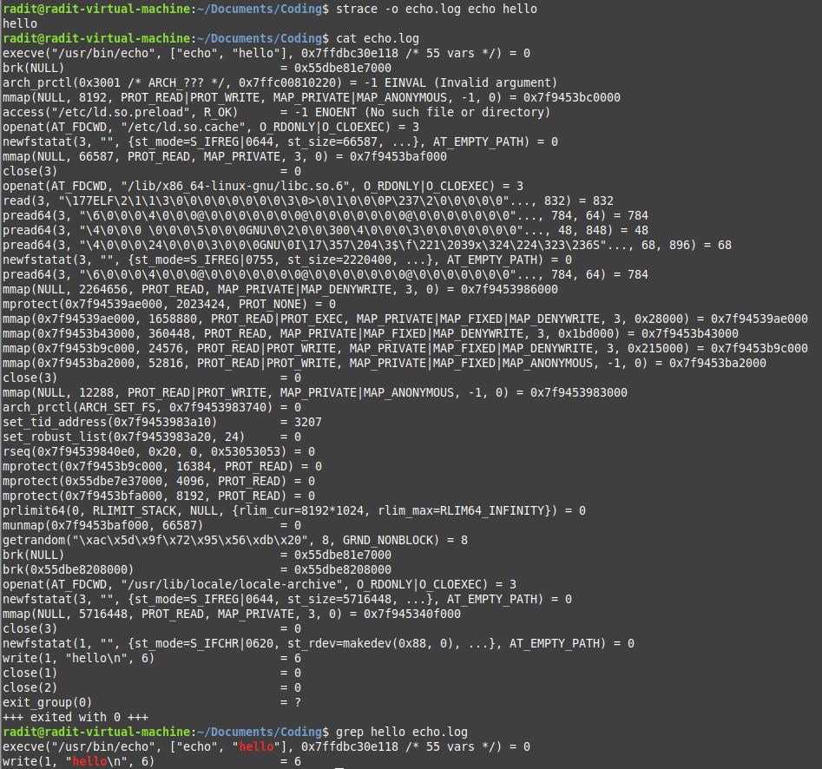

1. Filter the echo.log file to find text “hello” being mentioned

1. Explain what system call related to text in question number 2 is doing based on the manual page of the system call

Answer :

This line is using **execve** system call. The excve system call is used to execute a program. It is replacing the current process image with a new image. Also, there are some arguments like “usr/bin/echo” which is the path to the echo executed, ‘[“echo”, “hello”]’ the first element is the command name and the second element is the argument, and also there is a pointer and return value (0).

This line is using **write** system call. The write system call is used to write data to file descriptor. And there are some arguments like “hello\n” which the string being stdout and “6” is indicating number bytes to write because “hello\n” is 6 bytes long, 5 char plus newline. Also it has return value 6 indicates 6 bytes successfully written to stdout.